Week 6: Mobile Application Development
Student Name: Precious Jaiyesimi Eniola
Admission number: BIT/2024/39050
Course: Mobile Application Development
School/Faculty: Computing and Informatics, Mount Kenya University_
Program: Information Technology
Academic Year: 4th
Semester: First
Lecturer: Mr Nyoro

Task Completed

Login Screen
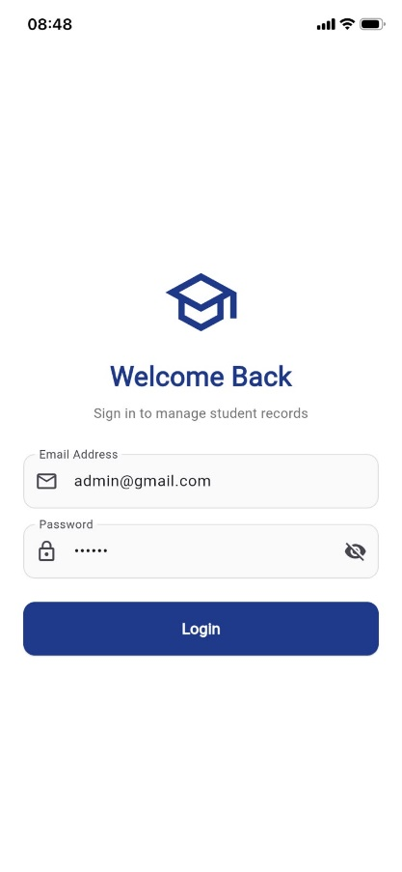

DashBoard screen

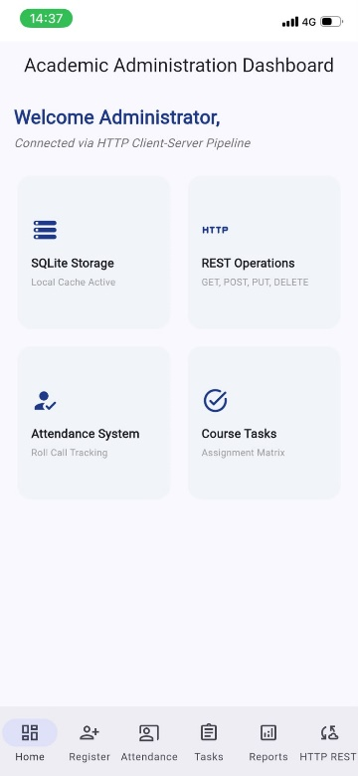

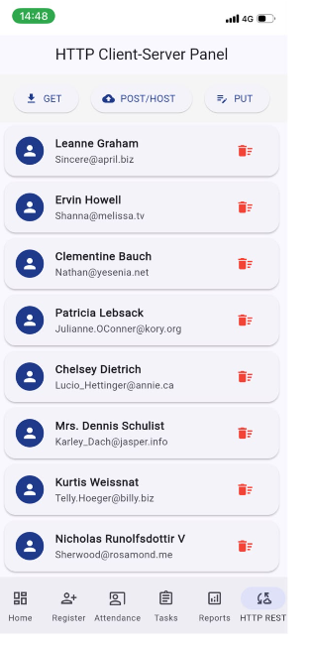
Network Screen

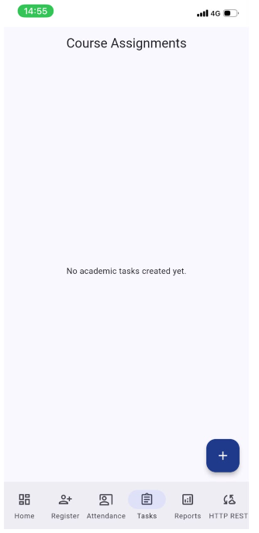
Course Screen
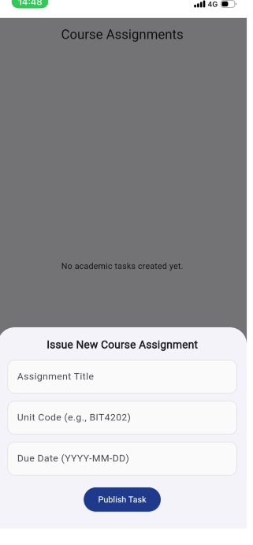

Tools/Software Used
- Flutter & Dart SDK
- Visual Studio Code (VS Code)
- Windows PowerShell (as Administrator)
- Windows Command Prompt (cmd)
- IPConfig (ipconfig)
- Windows Defender Firewall
- Windows .NET System.Net.HttpListener
- iPhone Personal Hotspot
- Safari Browser (iOS)
- iOS Home Screen Web App Engine (PWA)

Personal Reflection
Deploying my Flutter application onto my iPhone using a native Windows PowerShell web server over a mobile hotspot was an eye-opening troubleshooting experience. Wiping the caches, adjusting the firewall rules, and successfully routing database requests manually taught me how to adapt cross-platform web builds under restrictive presentation conditions.

